Project Development Phase
Model Performance Test
Date | 28 September 2026
Team ID | 6ab221fbe880316a482c6241
Project Name | Script-Controlled ACL – Restrict Record Access Based on Field Value
Maximum Marks | 10 Marks

Model Performance Testing:
Project team shall fill the following information in model performance testing template.
S.No. | Parameter | Values | Screenshot
1. | Metrics | Regression Model:  MAE - Not applicable, MSE - Not applicable, RMSE - Not applicable, R2 score - Not applicable  Classification Model:  Confusion Matrix - Not applicable, Accuracy Score & Classification Report - Not applicable  Note: This project uses a script-controlled ACL, not an ML model. Performance is verified by functional test cases: EEE branch user – record visible (Pass); other branch user – access denied (Pass). | 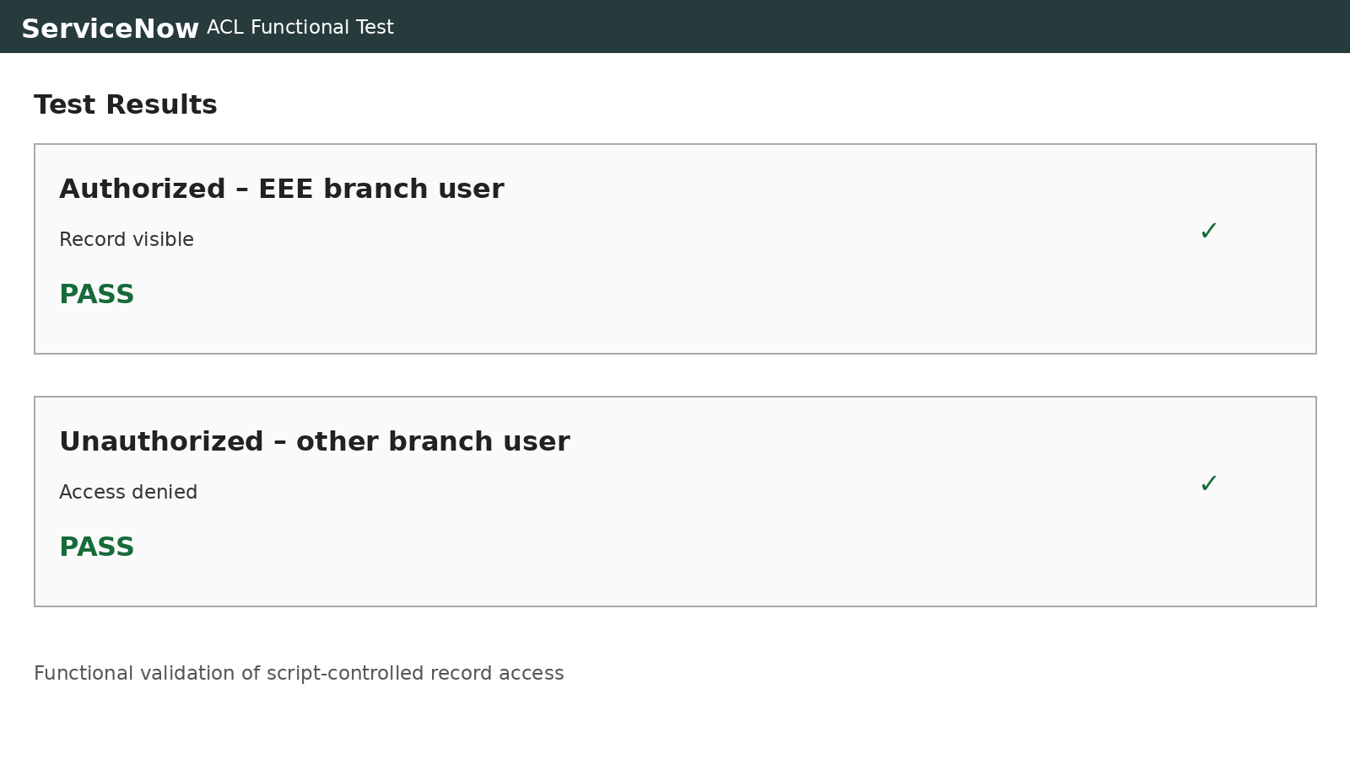  Test results
2. | Tune the Model | Hyperparameter Tuning - Not applicable (no ML model used)  Validation Method - Functional testing of the ACL script with authorized and unauthorized users | 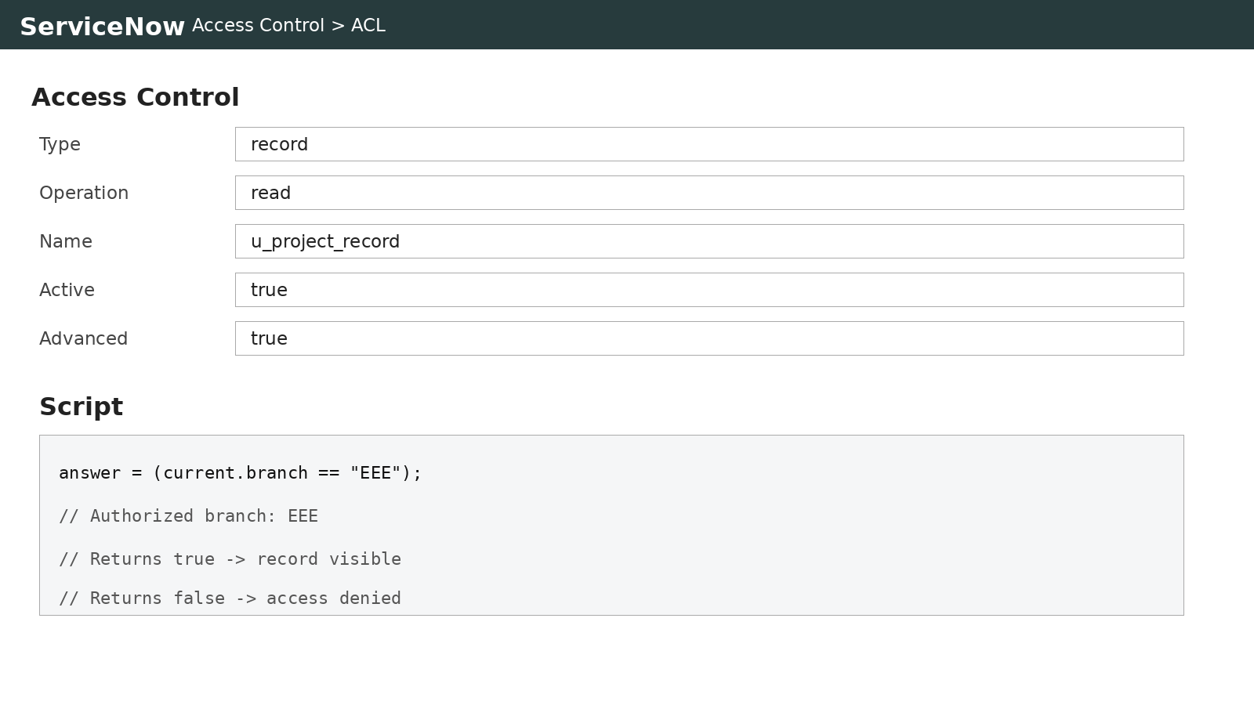  ACL script / validation

